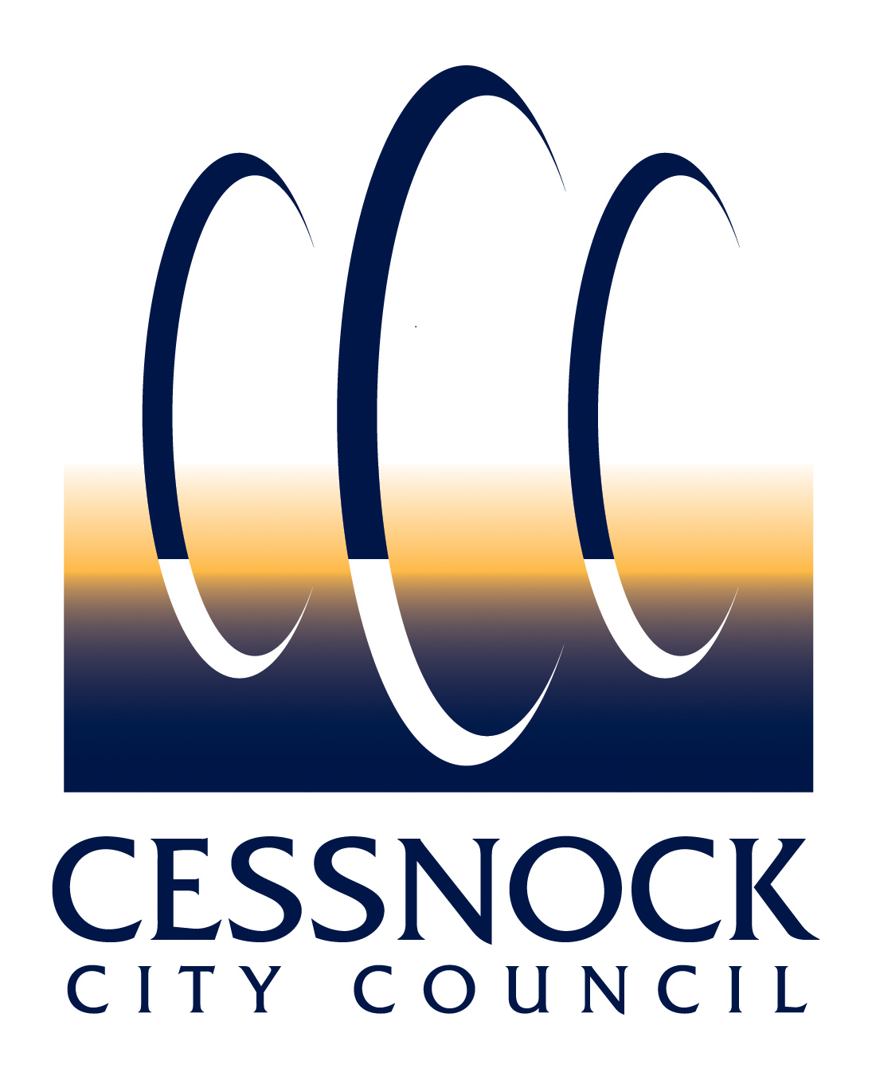 | CEMETERIES
 | LICENCE TO WORK IN COUNCIL CEMETERIES APPLICATION
 | Place stamp here (Office use)

APPLICATION INFORMATION
Please submit this application to Council’s Cemetery Officer along with required supporting documents via email cemetery@cessnock.nsw.gov.au. If you require any information, please call Council on (02) 4993 4100.
Please complete all of the following sections in PRINTED BLOCK LETTERS only
SECTION 1 – APPLICANT DETAILS
Company Name: |  |  |  |  |  |  |  |  | Contact Name:
Address:
Suburb: |  |  |  |  |  |  |  |  |  | State: |  |  |  | Postcode:
Postal Address (if different):
Phone Numbers: |  |  | (H) |  |  |  | (W) |  |  |  |  | (M)
Email:

SECTION 2 – LICENCE DETAILS
☐ Funeral Directors Association of NSW |  |  |  | ☐ Monumental Masons Association of NSW
TYPE OF LICENCE AND QUANTITY REQUIRED
box |  | Quantity | List names of employees who require a licence
☐ | Grave Digger
☐ | Funeral Director
☐ | Monumental Mason

SECTION 3 – DOCUMENTS TO BE SUBMITTED WITH THIS APPLICATION
☐ | Certificate of Currency for Public Liability Insurance – minimum $10M
☐ | Certificate of Currency for Workers Compensation Insurance
☐ | Certificate of Currency for Comprehensive Vehicle Insurance – minimum $20M
☐ | Work Health & Safety (WH&S) 2011 General Induction
☐ | Toolbox Checklist
☐ | Safe Work Method Statement / Site Risk Assessment

SECTION 4 – FEES AND CHARGES (As per Council’s Current Adopted Fees & Charges)
Single licence | $ | 125.00
Five or more licences (capped) | $ | 550.00

SECTION 5 – APPLICANTS ACKNOWLEDGMENT/DECLARATION
I, the undersigned Applicant: ( box)
☐ | wish to apply for a licence to work in Council’s cemeteries in accordance with Council’s current Fees and Charges;
☐ | understand and will adhere to the terms and conditions accompanying this application; and
☐ | state that all the information I have provided with respect to this application is true and accurate.
(Full Name of Applicant) |  | (Signature of Applicant) | (Date: DD/MM/YYYY)

OFFICE USE ONLY
(Cemetery Officer Name) | (Cemetery Officer Signature) | (Date: DD/MM/YYYY)

SECTION 6 – PRIVACY DISCLOSURE
Council is committed to safeguarding the privacy of individuals and handling of personal information in accordance with the Privacy and Personal Information Act 1998 (NSW) and Information Privacy Principles, the Health Records and Information Privacy Act 2002 (NSW) and Health Privacy Principles, and any subordinate legislation.
Purpose | The personal information on this form is collected for the purpose of Council performing its functions with respect to interments and complying with its legislative and regulatory requirements pursuant to the Cemeteries and Crematoria Act 2013 (NSW) and Part 8 of the Public Health Regulation 2012 (NSW) (the cemeteries legislation). The personal information will be used/handled in accordance with Council's Privacy Management Plan and Privacy Statement which can be found on Council’s website.
Intended Recipients | The intended recipients of the personal information collected are Council officers, government agencies and other bodies as required by law. The information will also form part of a public record that must be made available for inspection pursuant to the cemeteries legislation.
Supply | The supply of personal information is voluntary however if it is not provided, Council cannot process/progress your application.
Storage and Security | Personal information collected will be kept in Council's Information Management System in accordance with the relevant legislation. Council's address is 62-78 Vincent Street, Cessnock NSW 2325.
Access | Individuals may access, correct or update their personal information by visiting Council’s website, contacting Council's Privacy Contact Officer on (02) 4993 4100 or by sending an email to council@cessnock.nsw.gov.au.

SECTION 7 – TERMS AND CONDITIONS
DEFINITIONS
‘Act’ means the Cemeteries and Crematoria Act 2013 (NSW).
‘Council’ means Cessnock City Council and is the Cemetery Authority.
‘columbarium’ means a room or building with niches for funeral urns to be stored.
‘funeral director’ means an individual or business licensed to carry out funeral services.
‘Interment’ means the placement of human remains in a mausoleum, vault, columbarium or other structure designed for the placement of such remains or the burial in the earth of human remains (directly in the earth or within a container).
‘Interment Right’ means the contract with Council that allows interments to take place in a particular location in a cemetery. There is no entitlement to any real estate – the ownership of the land, wall, garden or memorial boulder remains with Council. An Interment Right was previously known as a right of burial or burial licence.
‘Interment Right Holder’ means the person who has the sole authority to determine who can be interred in the site and to allow Council approved memorials to be placed.
‘perpetuity’ means lasting indefinitely with no fixed end date.
GENERAL
- Council’s provision of services with respect to this application is subject to the applicant, Interment Right Holder and/or their agent (e.g. funeral director):
- have provided true and accurate information, and
- have provided necessary documentation including but not limited to a Death Certificate, Certificate of Currency, and
- have adhered to these terms and conditions, and
- have adhered to Council’s Cemetery Policy and supporting documents, other related policies, documents and practices as amended from time to time available on Council’s website, and
- have adhered to the Act, Part 8 of the Public Health Regulation 2012 (NSW), the Work Health and Safety Act 2011 (NSW), the Heritage Act 1977 (NSW).
Council reserves the right not to process this application, and/or to provide services, wholly or in part.
- Council reserves the right to review and/or amend these terms and conditions, its holdings, interment sites and property within its cemeteries at any time without notice to any person.
- To comply with the Act and Part 8 of the Public Health Regulation 2012 (NSW), Council is required to enter the details provided to it in a register available to the public for inspection.
INTERMENT RIGHTS
- Council may accept and process any application concerning an Interment Right from any person/s declaring they are authorised to do so (upon provision of written or documentary evidence and payment of the associated fee).
- Council reserves the right to refuse to grant or transfer an Interment Right to any person.
- No more than two Interment Rights in a cemetery can be held for any individual person.
- Interment Rights issued to multiple applicants are held jointly. On the death of a joint holder of an Interment Right, it passes on to the remaining joint Interment Right Holder/s.
- The Interment Right application fee does not include extras, e.g. maintenance fee, memorial permit fee, interment site digging fees, other administrative charges.
- The Interment Right Holder/s preferred funeral director is responsible for coordinating the Interment and funeral arrangements.
- Council may repurchase unused Interment Rights from the Interment Right Holder/s in accordance with the Act.
- An Interment Right can form part of a personal estate and be bequeathed, if not used.
- Interment Rights can be transferred, after consultation with Council. Transfer of the Interment Right is only operative when a transfer of Interment Right Application is submitted with payment of the associated fee, and processed by Council.
- Unused Interment Rights can be transferred pursuant to the will or intestacy of a deceased Interment Right Holder/s. In this instance, the transfer of the Interment Right is only operative when a transfer of Interment Right application is submitted with payment of the associated fee, and processed by Council.
- Monument ownership and all the responsibilities therein, reside with the Interment Right Holder/s and his/her Executor/heirs and successors to the grave where the monument is erected.
- A perpetual Interment Right must be used by the Interment Right Holder/s within 50 years of purchase. If it is not used within this period, Council can revoke the Interment Right.
- At its discretion, Council reserves the right to rescind allocation if an interment site is not paid for within one month from the date of reservation. If the interment site is next to a family grave, the family will be contacted about whether or not they still want the site. If Council is unable to make contact to the relevant people, Council will move forward in revoking the interment site. Interment site prices apply at the time that payment is made.
CERTIFICATE OF OWNERSHIP
- A certificate will be issued to the Interment Right Holder/s as proof of ownership and must be presented when booking an Interment service.
- A replacement certificate may be issued if the original certificate is lost, stolen or destroyed, on application and payment of the Council’s associated fee.
NICHE WALL AND MEMORIAL GARDEN SUITES
- Council is responsible for all vegetation maintenance of Interment plots.
- Council reserves the right to realign or alter the position of the garden and/or niches at its discretion.
- Council will not be liable for the repair, maintenance, upkeep or preservation of any plaque/plinth or item placed in the niche wall or memorial garden suites.
- Glass or other items that Council deems to be a safety hazard are not permitted in Council’s cemeteries, and if necessary may be removed without notice to any person.
- No monument, memorial, inscription, token plant, floral tributes, containers or such like are to be erected or placed on or within the lawn and garden section of the cemetery other than those allowed and supplied by Council. No ornaments or ceramics are to be placed on or around plaques, no glass vessels and no protruding objects above flower height in Council vases. Council may remove and/or dispose of any unauthorised item without notification to any person.
ASHES
- Ashes are held free of charge at Council awaiting placement, however no responsibility can be accepted for the ashes. Any residual remains being held for collection will be held for a period of six months from placement after which those remains will be disposed of, without notice to the person who requested the remains to be held, by scattering in a garden at the cemetery of placement.
- Interment of ashes in memorial gardens, columbarium walls and modern lawn cemeteries will be undertaken by Council. Interment Right Holder/s will be notified by telephone within 24 hours of the interment of ashes.
GRAVES
- Graves can usually be dug to a depth to accommodate two coffins or caskets. However, occasionally, due to rock or stability problems, not evident prior to commencement of digging the grave, ground conditions may not allow for burial in an allocated plot. In these circumstances an alternate plot will be allocated.
MEMORIALS
- Subject to the following, a memorial to the deceased person can be erected upon the Interment site:
  - Provided it is of the type allowed under Council’s policy/procedures and requirements, in that specific Interment section.
  - No memorial may be erected without Council’s prior written approval.
  - No existing memorial may be altered or removed without Council’s prior written approval.
  - Council reserves the right to refuse permission for any proposed memorial construction or alteration in its absolute discretion without assigning any reason. Council has the right (but not the obligation) to remove any unapproved memorial or alteration without notice to any person.
  - If an existing memorial impedes the conduct of the interment, Council may require it to be removed, at the applicant’s expense.
  - Scattered cremated remains are irretrievable.
  - Maintenance of monuments is solely the responsibility of the Interment Right Holder. Council will only assume responsibility where public safety has been identified and only when the Interment Right Holder cannot be contacted. Council reserves the right to recover these costs from the Interment Right Holder.

