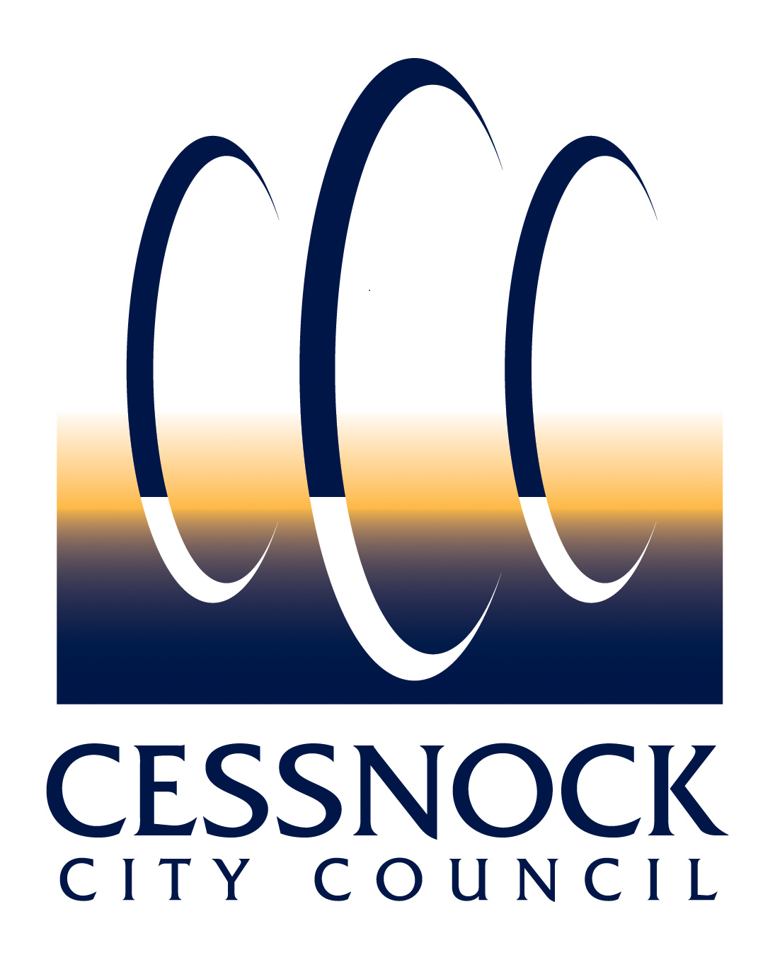 | CEMETERIES
RELOCATE ASHES
APPLICATION
 | Place stamp here (Office use)

APPLICATION INFORMATION
Please submit this application to Council’s Cemetery Officer via email cemetery@cessnock.nsw.gov.au. If you require information, or would like to make an appointment, please call Council on (02) 4993 4100.
Please complete all of the following sections in PRINTED BLOCK LETTERS only
SECTION 1 – INTERMENT RIGHT HOLDER DETAILS
Given Name/s: |  |  |  |  |  |  |  |  |  | Surname:
Address:
Suburb: |  |  |  |  |  |  |  |  |  |  |  | State: |  |  |  | Postcode:
Postal Address (if different):
Phone Numbers: |  |  |  | (H) |  |  |  | (W) |  |  |  |  |  | (M)
Email:
Interment Right Holder Deceased? |  |  |  |  |  |  | ☐ Yes (please provide documentation verifying executor/authority/statutory declaration)
 |  |  |  |  |  |  | ☐ No

SECTION 2 – CURRENT LOCATION OF ASHES
Name of Deceased:
Cemetery: |  |  |  |  |  |  |  | Denomination:
Row: |  |  | Section: |  |  | Plot: |  |  | Wall: |  |  | Niche:

SECTION 3 – NEW LOCATION OF ASHES
Cemetery: |  |  |  |  |  |  | Denomination:
Row: |  |  | Section: |  | Plot: |  |  | Wall: |  |  | Niche:

SECTION 4 – FEES AND CHARGES (As per Council’s current adopted Fees & Charges)
Fee to Relocate Ashes | $
Administration Fee | $
New Plaque Fee | $
Total Cost | $

SECTION 5 – AUTHORITY TO TRANSFER
I, the undersigned Executor/Authority: ( box)
☐ | wish to relocate the ashes of the plot recorded in Section 2 to new location nominated in Section 3 above;
☐ | understand the cost for the plaque and placement is my responsibility;
☐ | will advise Council if I would like the existing plaque returned;
☐ | understand and will adhere to the terms and conditions accompanying this application; and
☐ | state that all the information I have provided with respect to this application is true and accurate.
(Full Name of Executor/Authority) |  | (Signature of Executor/Authority) | (Date: DD/MM/YYYY)

OFFICE USE ONLY
(Cemetery Officer Name) | (Cemetery Officer Signature) | (Date: DD/MM/YYYY)

SECTION 6 – PRIVACY DISCLOSURE
Council is committed to safeguarding the privacy of individuals and handling of personal information in accordance with the Privacy and Personal Information Act 1998 (NSW) and Information Privacy Principles, the Health Records and Information Privacy Act 2002 (NSW) and Health Privacy Principles, and any subordinate legislation.
Purpose | The personal information on this form is collected for the purpose of Council performing its functions with respect to interments and complying with its legislative and regulatory requirements pursuant to the Cemeteries and Crematoria Act 2013 (NSW) and Part 8 of the Public Health Regulation 2012 (NSW) (the cemeteries legislation). The personal information will be used/handled in accordance with Council's Privacy Management Plan and Privacy Statement which can be found on Council’s website.
Intended Recipients | The intended recipients of the personal information collected are Council officers, government agencies and other bodies as required by law. The information will also form part of a public record that must be made available for inspection pursuant to the cemeteries legislation.
Supply | The supply of personal information is voluntary however if it is not provided, Council cannot process/progress your application.
Storage and Security | Personal information collected will be kept in Council's Information Management System in accordance with the relevant legislation. Council's address is 62-78 Vincent Street, Cessnock NSW 2325.
Access | Individuals may access, correct or update their personal information by visiting Council’s website, contacting Council's Privacy Contact Officer on (02) 4993 4100 or by sending an email to council@cessnock.nsw.gov.au.

SECTION 7 – TERMS AND CONDITIONS
DEFINITIONS
‘Act’ means the Cemeteries and Crematoria Act 2013 (NSW).
‘Certificate of Perpetual Interment Right’ means a document that established a legal right with Council to allow Interment to take place in a specified location in a specified cemetery.
‘Council’ means Cessnock City Council and is the Cemetery Authority.
‘Columbarium’ means a room or building with niches for funeral urns to be stored.
‘Fee’ means amount of payment in accordance with Council’s published Fees and Charges.
‘Funeral Director’ means an individual or business licensed to carry out funeral services.
‘Interim Certificate of Perpetual Interment Right’ means a document that established a legal right with Council to allow Interment to take place in a specified location in a specified cemetery, subject to full payment of the application Fee and issue of a Certificate of Perpetual Interim Right.
‘Interment’ means the placement of human remains in a mausoleum, vault, Columbarium or other structure designed for the placement of such remains or the burial in the earth of human remains (directly in the earth or within a container).
‘Perpetual’ or ‘Perpetuity’ means lasting indefinitely with no fixed end date.
‘Perpetual Interment Right’ means the contract with Council that allows Interment to take place in a specified location in a specified cemetery. There is no entitlement to any real estate – the ownership of the land, wall, garden or memorial boulder remains with Council. An Interment Right was previously known as a right of burial or burial licence.
‘Perpetual Interment Right Holder’ means the person who has the sole authority to determine who can be interred in the Site and to allow Council approved memorials to be placed.
‘Register’ means the cemetery operator’s register required in accordance with the Act.
‘Site’ means the plot location and lot and will be specified in the Certificate of Perpetual Interment Right.
GENERAL
- Council’s provision of cemetery services is subject to the applicant, Interment Right Holder and/or their agent (e.g. Funeral Director):
  - providing true and accurate information, and
  - completing relevant application forms and providing necessary documentation, including but not limited to a Death Certificate or Certificate of Perpetual Interment Right, and
  - paying any associated Fee, and
  - adhering to these terms and conditions, and
  - adhering to Council’s Cemetery Policy and supporting documents, other related policies, documents and practices as amended from time to time available on Council’s website, and
  - adhering to the Act, Part 8 of the Public Health Regulation 2012 (NSW), the Work Health and Safety Act 2011 (NSW), and the Heritage Act 1977 (NSW).
- Council reserves the right not to process applications, and/or to provide services, wholly or in part.
- Council reserves the right to review and/or amend these terms and conditions, its holdings, Interment Sites and property within its cemeteries at any time without notice to any person.
- To comply with the Act and Part 8 of the Public Health Regulation 2012 (NSW), Council is required to enter the details provided to it in a register available to the public for inspection.
APPLICATION AND FEES AND CHARGES
- Any Fee required to accompany an application is for the relevant application processing only and does not include additional fees that may be incurred at the time of need for Interment or for additional or alternate applications.
- A Fee associated with a Perpetual Interment Right relates to the application and granting of the right only and not to any other costs associated with an Interment.
- Where an applicant enters into a payment plan in relation to an Interim Certificate of Perpetual Interment, and requires the Site prior to the payment plan being completed, any outstanding amount remaining will be required to complete full payment at the time of need of Interment.
- There may be additional charges that may be incurred at the time of need of Interment including but not limited to Site digging Fees, memorial permit Fees, Funeral Director Fees, other administrative charges. In addition, there may be ongoing maintenance Fees.
PERPETUAL INTERMENT RIGHTS
- Council may accept and process any application concerning a Perpetual Interment Right from any person/s declaring they are authorised to do so (upon provision of written or documentary evidence and payment of the associated fee).
- No more than two Perpetual Interment Rights in a cemetery can be held for any individual person.
- A Perpetual Interment Right issued to two or more applicants is held jointly. On the death of a joint holder of a Perpetual Interment Right, the Perpetual Interment Right passes to the remaining Perpetual Interment Right Holder. The remaining Perpetual Interment Right Holder must advise Council who will update the Register accordingly.
- Council may repurchase unused Interment Rights from the Interment Right Holder/s in accordance with the Act.
- An Interment Right can form part of a personal estate and be bequeathed, if not used an unused Perpetual Interment Right may be transferred on application to Council and payment of the associated fee. Transfer of the Perpetual Interment Right is only operative when Council issues a new Certificate of Perpetual Interment Right and updates the Register. An unused Perpetual Interment Right can be transferred pursuant to the will or intestacy of a deceased Perpetual Interment Right Holder on application to Council and payment of the associated fee. Transfer of the Perpetual Interment Right is only operative when Council issues a new Certificate of Perpetual Interment Right and updates the Register.
- Council reserves the right to refuse to grant or transfer a Perpetual Interment Right in accordance with the Act.
- A Perpetual Interment Right Holder may apply to Council to cancel an unused Perpetual Interment Right.
- Council may repurchase unused Perpetual Interment Rights from the Perpetual Interment Right Holder in accordance with the Act.
- A Perpetual Interment Right must be used by the Perpetual Interment Right Holder within 50 years of the date of issue of the Certificate of Perpetual Interment Right. If it is not used within this period, Council can revoke the Perpetual Interment Right, in accordance with the Act.
- Applications to amend a Perpetual Interment Right will be considered on application to Council and payment of the associated Fee. Amendment of the Perpetual Interment Right is only operative when Council issues a new Certificate of Perpetual Interment Right and updates the Register.
CERTIFICATE OF PERPETUAL INTERMENT RIGHT
- A Perpetual Interment Right is not effective until Council issues a Certificate of Perpetual Interment Right and updates the Register.
- An Interim Certificate of Perpetual Interment Right may be issued by Council to indicate that a Perpetual Interment Right Holder has entered into a payment agreement with Council, and once full payment of the application fee has been received, Council will issue a Certificate of Perpetual Interment Right and update the Register.
- At its discretion, Council reserves the right to rescind allocation of a site if the full fee is not paid within 12 months from the date of application, or at the time of Interment if earlier, in accordance with the Interim Certificate of Perpetual Interment Right. If the Interment Site is next to a family grave, the family will be contacted about whether or not they still want the site. If Council is unable to make contact to the relevant people, Council will move forward in revoking the Interment Site. Interment Site prices apply at the time that payment is made.
- A Certificate of Perpetual Interment Right will be issued to the Perpetual Interment Right Holder as proof of Perpetual Interment Right and must be presented when booking an Interment service.
- A replacement Certificate of Perpetual Interment Right may be issued if the original is lost, stolen or destroyed, on application to Council and payment of any associated fee.
INTERMENT IN GENERAL CEMETERY
- The preferred Funeral Director of the Perpetual Interment Right Holder is responsible for coordinating the Interment and funeral arrangements.
INTERMENT IN LAWN CEMETERY
- Council is responsible for the Interment of ashes in memorial gardens, Columbarium, niche walls, and modern lawn cemeteries. The Perpetual Interment Right Holder will be notified by telephone within 24 hours of the Interment of ashes.
TRIBUTES
- Lawn Cemeteries -
No monument, memorial, inscription, token plant, floral tributes, containers or such like are to be erected or placed on or within the lawn and garden section of the cemetery other than those allowed and supplied by Council. No ornaments or ceramics are to be placed on or around plaques, no glass vessels and no protruding objects above flower height in Council vases. Council may remove and/or dispose of any unauthorised item without notification to any person.
- General Cemeteries -

No glass, ceramics, ornaments are permissible. All floral tributes must be placed on or within the internment site. Council may remove and/or dispose of any unauthorised item without notification to any person.
NICHE WALL AND MEMORIAL GARDEN SUITES
- Council is responsible for all vegetation maintenance of Interment sites.
- Council reserves the right to realign or alter the position of the garden and/or niches at its discretion.
- Council will not be liable for the repair, maintenance, upkeep or preservation of any plaque/plinth or item placed in the niche wall or memorial garden suites.
- Glass or other items that Council deems to be a safety hazard are not permitted in Council’s cemeteries, and if necessary may be removed without notice to any person.
ASHES
- Ashes are held free of charge at Council awaiting placement. All care will be undertaken, however no responsibly can be accepted for the ashes.
- Following placement, any residual remains being held for collection will be held for a period of six months from the date of placement after which those remains will be disposed of, without notice to the person who requested the remains to be held, by scattering in a garden at the cemetery of placement. Scattered ashes are irretrievable.
- Interment of ashes in memorial gardens, Columbarium walls and modern lawn cemeteries will be undertaken by Council. Interment Right Holder/s will be notified by telephone within 24 hours of the interment of ashes.
- Applications to relocate ashes may will be considered on application to Council and payment of any associated fee. Ashes that have been scattered are unable to be relocated.
- Applications to remove ashes and plaque will be considered on application to Council and payment of any associated fee.
GRAVES
- Graves can usually be dug to a depth to accommodate two coffins or caskets. However, occasionally, due to rock or stability problems, not evident prior to commencement of digging the grave, ground conditions may not allow for Interment in an allocated plot. In these circumstances an alternate plot will be allocated and a revised Certificate of Perpetual Interment Right issued and updating of the Register if required.
MEMORIALS
- Subject to the following, a memorial to the deceased person can be erected upon the Interment Site:
  - Provided it is of the type allowed under Council’s policy/procedures and requirements, in that specific Interment section.
  - No memorial may be erected without Council’s prior written approval.
  - No existing memorial may be altered or removed without Council’s prior written approval.
  - Council reserves the right to refuse permission for any proposed memorial construction or alteration in its absolute discretion without assigning any reason. Council has the right (but not the obligation) to remove any unapproved memorial or alteration without notice to any person.
  - If an existing memorial impedes the conduct of the Interment, Council may require it to be removed, at the Perpetual Interment Right Holder’s expense.
  - Scattered cremated remains are irretrievable.
  - Memorial ownership and all the responsibilities therein, reside with the Perpetual Interment Right Holder and his/her executor/heirs and successors.
  - Maintenance of memorials is solely the responsibility of the Perpetual Interment Right Holder. Council will only assume responsibility where public safety has been identified and only when the Perpetual Interment Right Holder cannot be contacted. Council reserves the right to recover these costs from the Perpetual Interment Right Holder or successors.
MAINTENANCE
- Council is responsible for cemetery maintenance including vegetation, cemetery structures, roadways and associated infrastructure.
COMPLAINTS HANDLING
- Council will acknowledge and attend to complaints in line with Councils adopted Complaint handling Policy and Procedure.
LICENSE TO WORK WITHIN CEMETERIES
- No works within Council cemeteries are permitted to be undertaken by any person not licenced to work within Council cemeteries.

