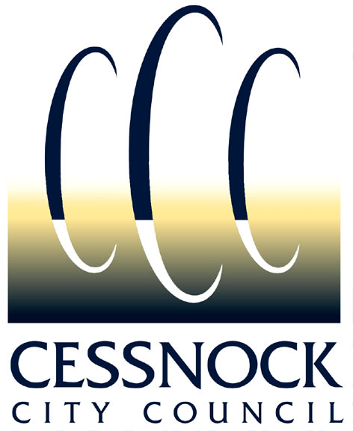

SCHOOLS ENVIRONMENT GRANTS
PROGRAM GUIDELINES

Background:

The Schools Environment Grants Program is part of the Sustainability in Action Program currently run by Council. Grants are offered once per year, with progress and final reports on projects being part of the regular Council schools environment newsletter. This program also looks for opportunities to engage schools to participate in other environmental initiatives (e.g. Landcare, Clean up Australia Day and Tidy Towns) that Council undertakes.

The objectives of the Schools Environment Grants program are:
- To integrate environmental improvement and school environmental management projects into the school curriculum and lesson plans.
- To encourage schools to undertake activities which address local environmental issues.
- To assist schools in protecting and enhancing their natural environment.
- To encourage student participation in environmental management within their school

Grant Guidelines:

- Grants are for a maximum amount of:
  - $1000 each for high schools,
  - $500 each for primary schools, and
  - $200 each for preschools.
Donated materials or voluntary labour should be valued and included as in-kind matching contributions, as well as any cash matching contributions available.

- Grants are offered to Schools for the purpose of meeting the program objectives above.

- Grants are available to all preschools and schools (infants, primary and secondary, public and private) in the Cessnock LGA that have an Australian Business Number.

- Grant applications will be prioritised on the basis of achieving the objectives of the program and priority will be given to schools who did not receive funding the previous year enabling every school equal opportunity to access this funding.

- Final reports on projects that have been previously funded must be submitted to Council at the project’s completion. Schools are ineligible to apply for further grants until reports of previous grants are received and approved by Council.

- Applications should address any ongoing maintenance and/or expenses associated with the proposed project.

- Projects should be completed within a twelve (12) month period, but longer or staged projects may be considered.

- The grant can only be used for the purpose approved by the Dollar for Dollar Committee. Any alterations to approved projects are subject to Council’s decision.

- If grants are for structures, relevant Development or Construction consent must be granted prior to Council funding being made available and grants can only be used for purposes approved by Council.

- Applications should be made to Cessnock City Council. An application form is available from Council’s website or from the Help and Information counter upon request.

- Applications will be considered by Council’s Dollar for Dollar Committee, which will make recommendations to Council. Funds will be distributed to the successful applicants as recommended.

- Council’s support for the funded project must be acknowledged whenever formal written and verbal references to the project are made, and on any promotional material regarding the project.

- Application must be submitted to Council no later than the closing date which is 4pm Friday 1 March 2024. Applications received after the closing date may not be assessed.

CESSNOCK CITY COUNCIL
SCHOOLS ENVIRONMENT GRANTS
PROGRAM APPLICATION FORM

SCHOOL NAME:
CONTACT NAME:
CONTACT ADDRESS:
PHONE NUMBER:
EMAIL:
POSITION WITHIN  ORGANISATION: |  |  |  |  |  |  |  | - Principal |  |  |  |  |  |  | - Teacher |  |  |  |  |  |  | - Other:

Australian Business Number:
(This is essential for all applications)

ARE YOU REGISTERED FOR GST: YES / NO

PROJECT LOCATION:
(School Name and Address)
PROJECT DESCRIPTION:
(Plans, site maps or supporting documents can be attached)
PURPOSE OF PROJECT:
(i.e. what purpose will the project serve or what problem/deficiency will it resolve?)

NET PROJECT COST (excluding GST): | $
GST | $
TOTAL COST OF PROJECT (including GST):  (documentation to support accuracy of project costs must be attached as per the attached checklist) | $

FUNDING SOUGHT FROM COUNCIL: | $
SCHOOLS CASH CONTRIBUTION: | $
SCHOOLS IN-KIND CONTRIBUTION: | $
TOTAL COST OF PROJECT (including GST):  (should match total above) | $

HAVE YOU DISCUSSED THE PROJECT WITH COUNCIL’S CONTACT OFFICER FOR THE GRANT SCHEME: | - Yes | - No

PROJECT ACTION PLAN
ACTION/STAGE OF PROJECT | ESTIMATED TIMEFRAME

ONGOING PROJECT COSTS: Are there likely to be any ongoing maintenance and/or expenses associated with this project?

- Yes (If yes, how will this be financed?)
- No

- I have read and accept the Schools Environment Grant Scheme Guidelines

Signature of Applicant Date

Closing Date:
4pm Friday 1 MARCH 2024

CHECKLIST

The following documentation should be attached to ensure compliance with the Grant Scheme Guidelines:

- ABN Supplied
- Site or location plan attached (where applicable)
- Product and/or project specifications (i.e. manufacturer, design, dimensions, construction information etc.)
- Discussed proposed project with relevant contact officer

CONTACT OFFICERS

Grant Scheme | Contact Officer | Phone Number(s)
Schools Environment | Sustainability Officers:  Daniela Gambotto (Mon-Wed)  Danielle Lloyd-Prichard (Wed-Thurs) | 4993 4342  4993 4163

